**Name : Pooja Patel**  (pp64131n@pace.edu)

**Snehal Rode** ([sr41593p@pace.edu](mailto:sr41593p@pace.edu))

**Group : 2**

**Scalable Databases FALL 2022**

**CRN :****72804**

**Project : Problem Statement**

In the Formula -1 dataset, we are going to analyze which country is participating in this world wide sport over the period of time.

Analysis of the constructor's world championship like which constructor team scores the highest points and its details.

Get the information about the Driver's championship and their points.

Number of races won by the driver and overall performance and its nationality, circuit name, code and other details.

Each analysis is defined along with the SQL query. Before we jump into the Query part.

Let’s first understand Formula - 1. Below is a quick overview of Formula - 1.

**Quick Overview about Formula - 1**

**What is Formula -1 ?**

* Formula 1 is an international auto racing sport. The short form of Formula 1 is F1.

**Objective :**

The goal of a Formula 1 competition is to choose the race's victor. After finishing a certain number of laps, the driver who crosses the finish line first is crowned the winner. Additionally, the amount of laps varies. Basically, it is race-dependent.

A season in Formula 1 allows teams to utilize a maximum of four drivers.

The "Formula 1 World Championship season" is a period of time during which a number of Formula 1 events are held.

Each race in a season is referred to as a "Grand Prix" or "GP," while the entire season's worth of events is referred to as a "Grand Prix." (It stands for "big reward").

The F1 races are held on specially constructed racetracks known as "circuits."

## **Grand Prix World Championship**

The results of all the Grand Prix races in a season are taken together to determine two annual Championship awards.

* **Drivers' Championship Award (for the drivers)**

The driver, who scores the most points in a Formula 1 World Championship season, is awarded the Formula 1 World Driver’s Championship. This award is given to the Driver.

* **Constructors' Championship Award (for the constructors)**

The constructor, who scores the most points in a Formula 1 World Championship season, is awarded the Formula One World Constructor’s Championship. This award is given to the Team.

# 

# **Formula 1 - Grand Prix Format**

A Formula 1 Grand Prix takes place over a weekend i.e., on 3 days − Friday, Saturday and Sunday. Different events take place on different Days.

* Friday − Practice Sessions
* Saturday − Practice Session and Qualifying Session
* Sunday − Race Day

**Practise Sessions :**

Every Grand Prix starts with 3 practice sessions, with 2 of them being on Friday; each sessions is 90 minutes. One session is in the morning and the other in the afternoon. The last practice session takes place on Saturday.

## **Qualifying Sessions :**

Qualifying Sessions decides which position is given to the driver at the time of Final Race.

## **Race Day :**

The main event of a Grand Prix, the race day, is held on a Sunday afternoon.

**For data Generation, we have used a dataset that we found from github in order to perform analysis of below tables.**

**Github dataset :** [**here**](https://github.com/toUpperCase78/formula1-datasets)

**Creation of Tables with constraints :**

**1) Table creation screenshot and the DDL query attached with documentation.**

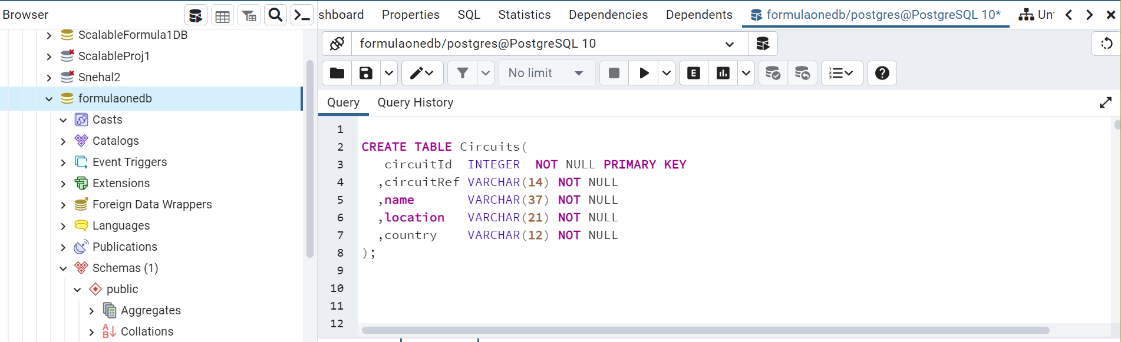

**Inserted data into Table**

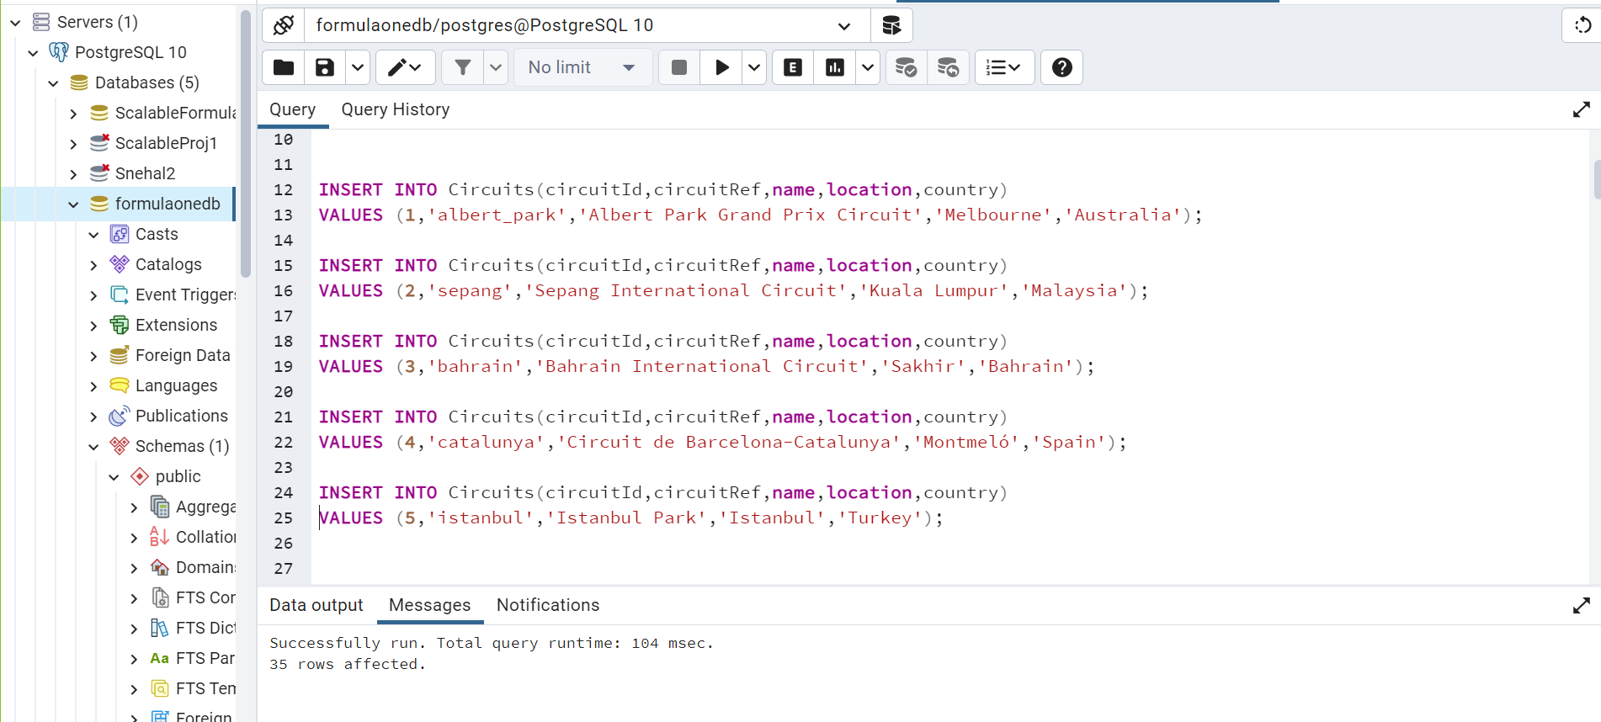

**Design a Schema based on tables and explain the schema :**

**Create Database :**

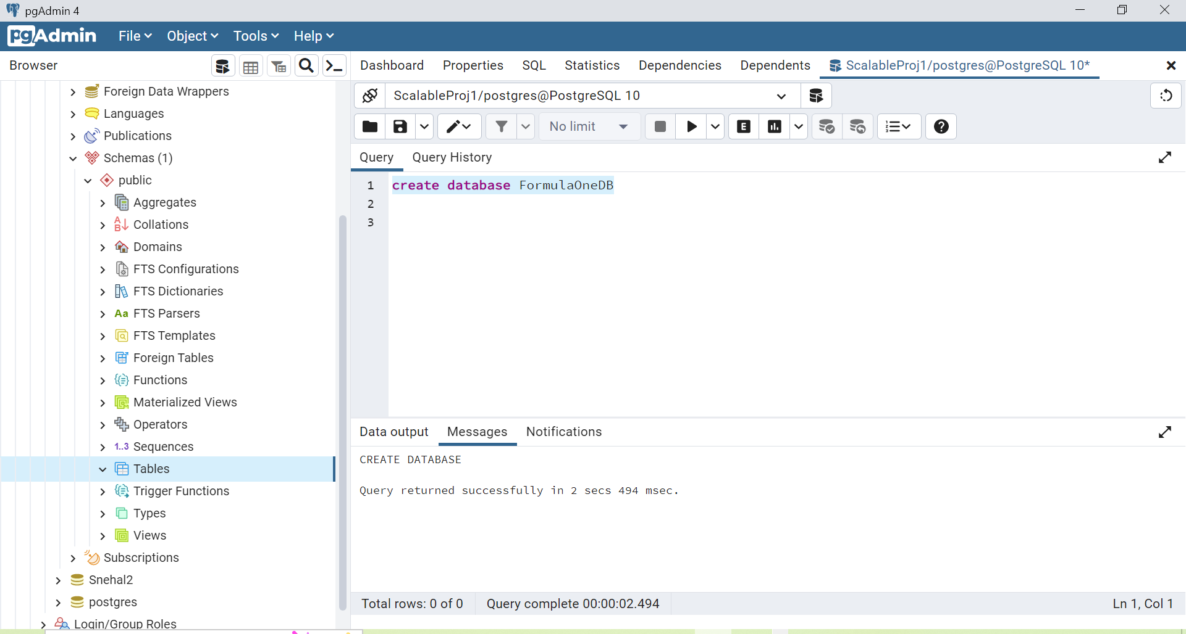

**List of tables :**

* **Circuit :** Racing tracks details
* **Driver :** Details of the Formula - 1 drivers
* **Races :** Details of Races
* **Constructors :** Team (Constructor) details
* **Constructor_results :** Results of each Team (Constructor)
* **Results :** Race results details

**Entity-Relationship diagram :**

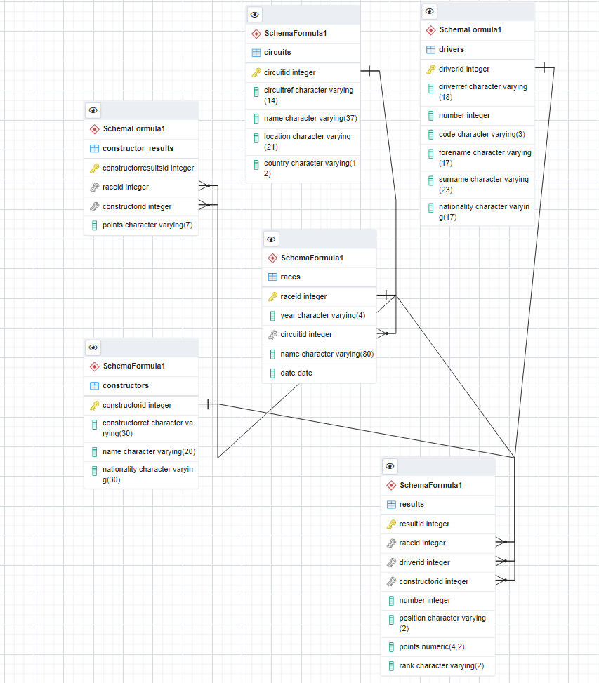

**Create primary keys, foreign keys :**

Note : Primary key and foreign key are created at the time of table creation. Please check the DDL of the table.

**Create Procedures :**

**-- Creating a Procedure which update constructor table's data**

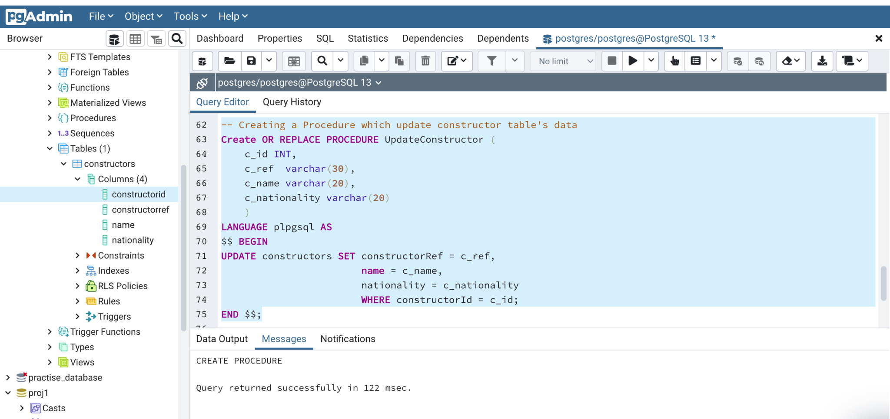

**-- calling procedure**

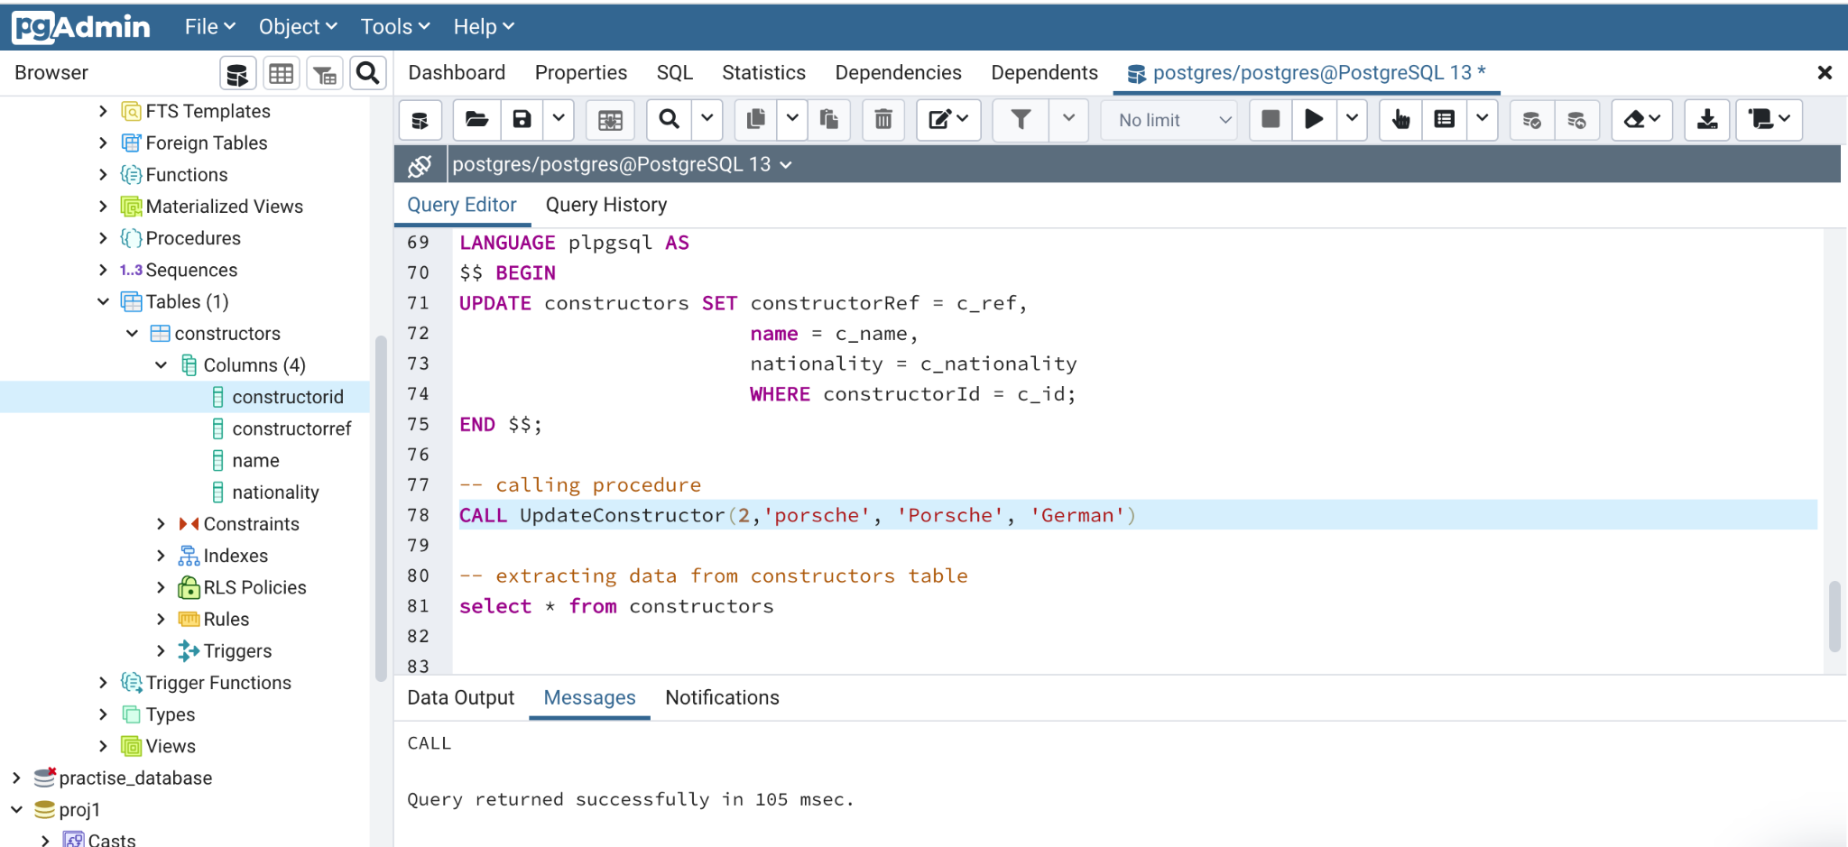

**-- executing results** 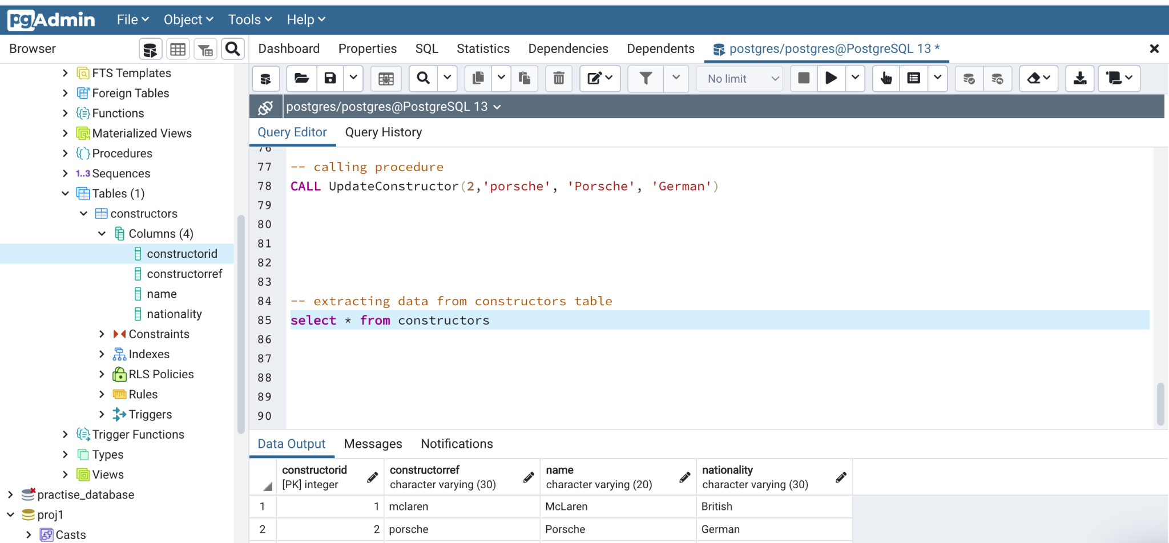

**Create functions :**

**-- creating a function which automatically insert records into constructor table based on the value user passed**

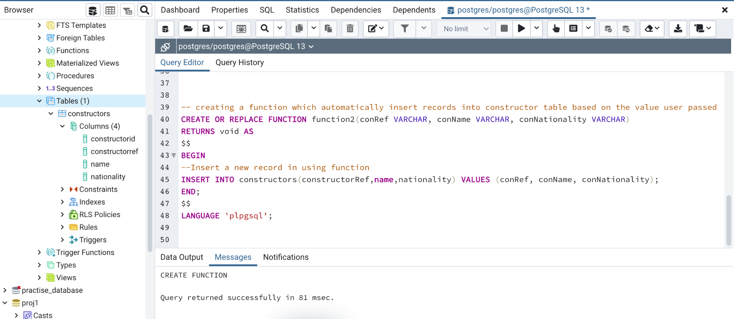

**-- inserted data using function**

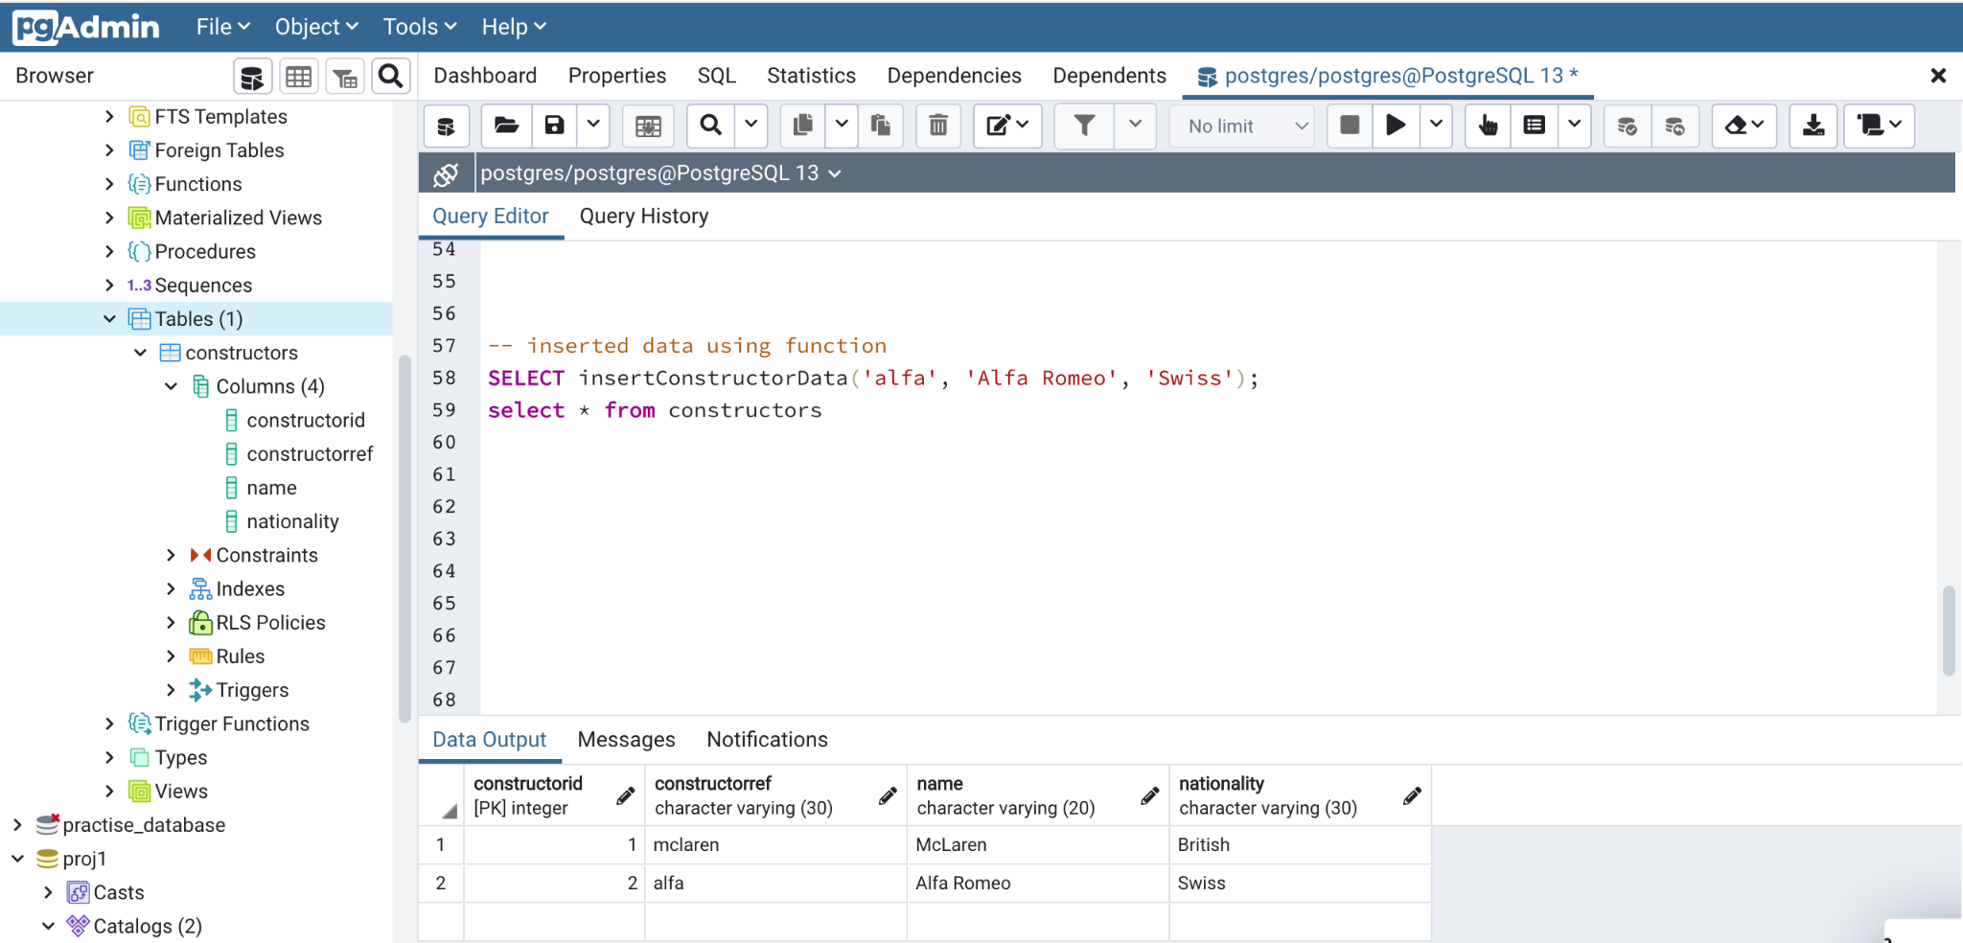

**Create Views :**

**-- Finding Circuits that have Organized the Race and its details :**

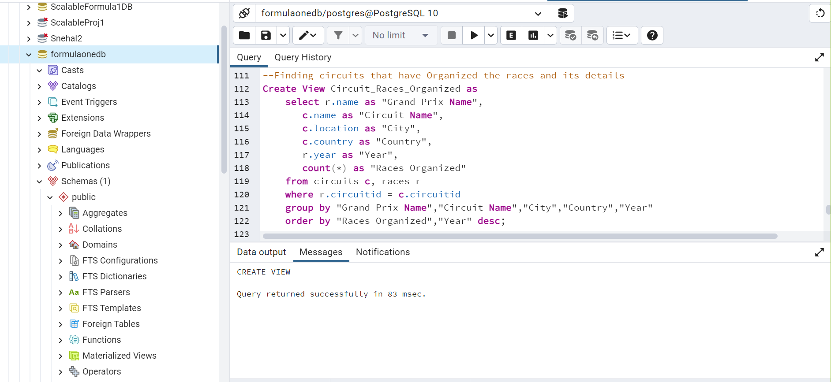

**-- executing views**

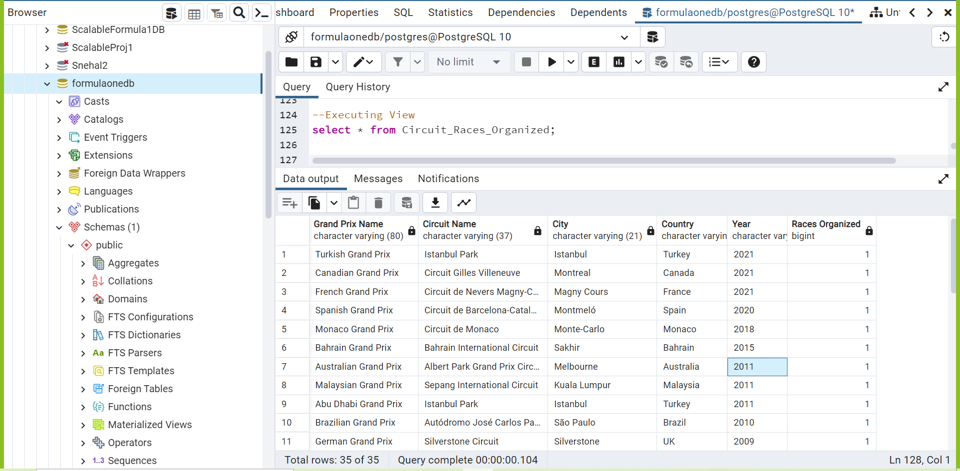

**Create Index :**

-- **Creating index of code in drivers table.**

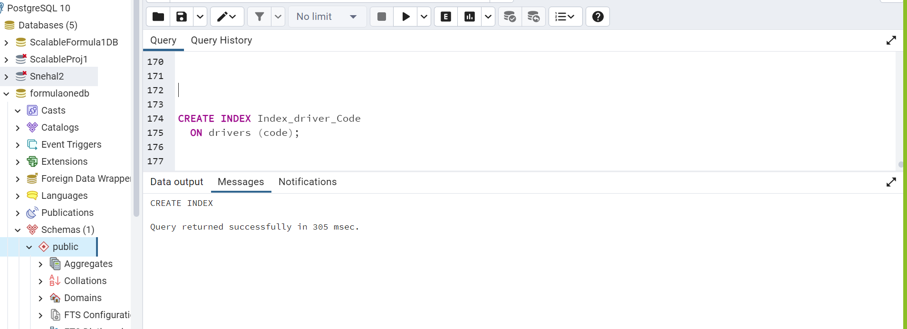

**SQL queries :**

**Query 1 : Finding the locations that organized the maximum races**

**(We have used count, groupby, orderby, where, desc)**

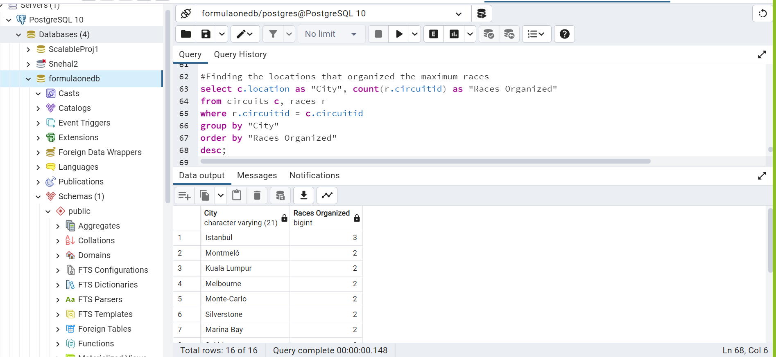

**Query 2 : Name of the Constructors who are having 10 or more total points of races**

**(we have used cast, sum, inner join, groupby, having, order by)**

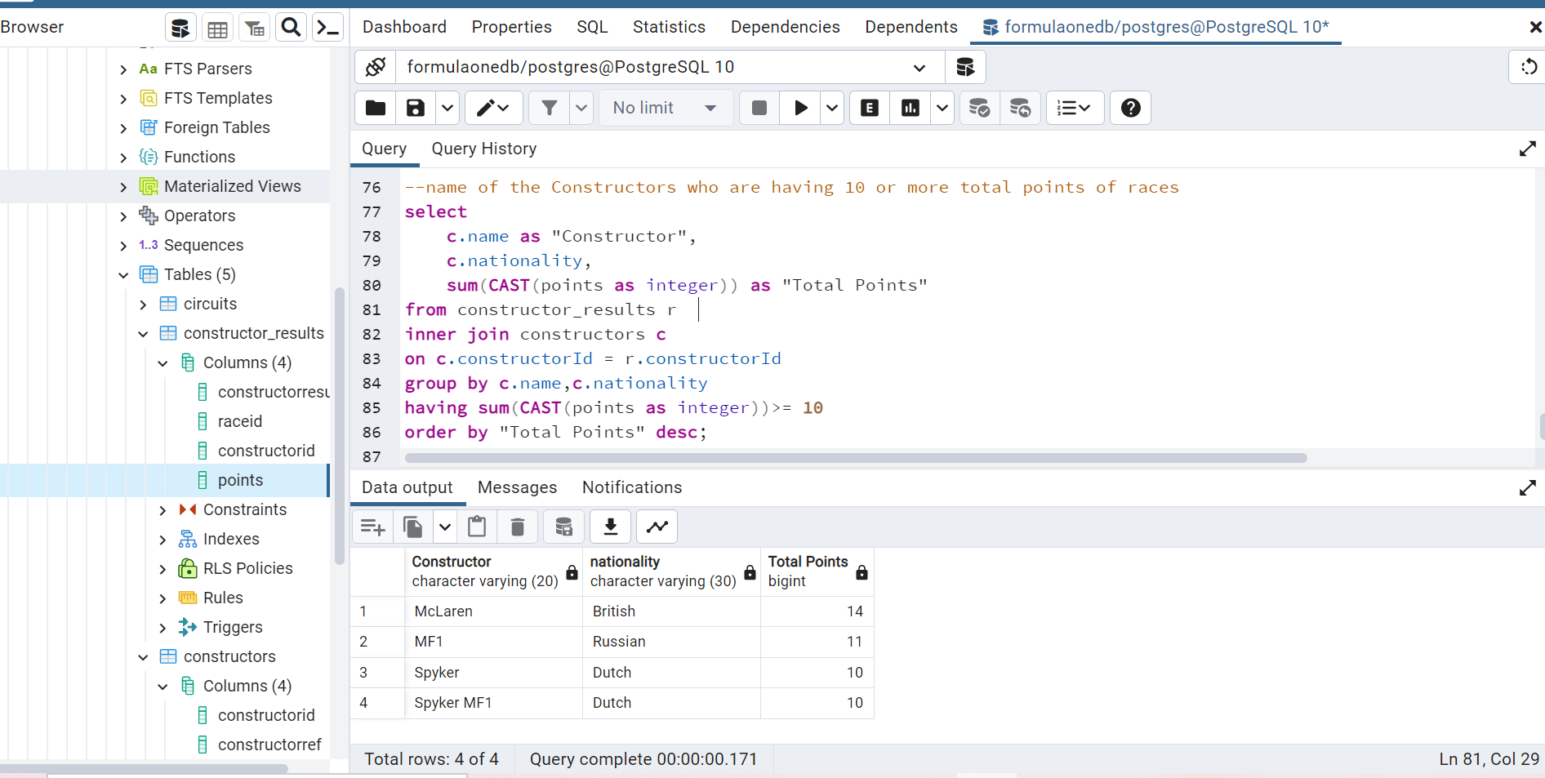

**Query 3 : Number of races won by top 5 drivers**

**(We have used Concat, between, limit)**

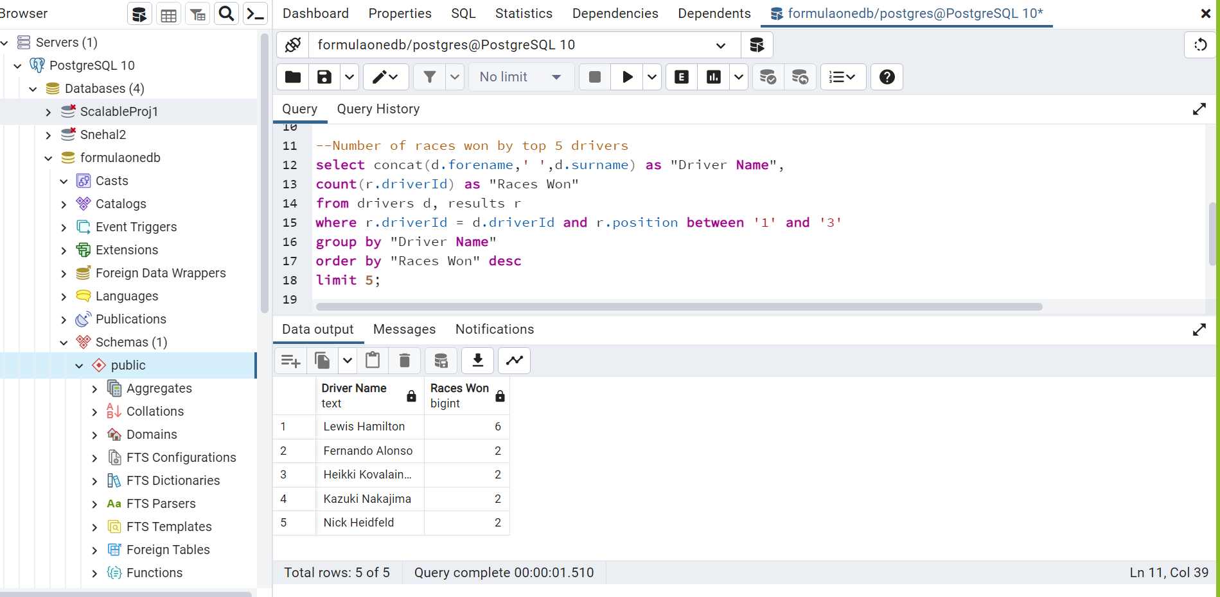

**Nested queries, Scalar Subquery :**

**Query 4 : Name of the constructors whose total points is greater than average points**

**(we have used subquery or nested query)** 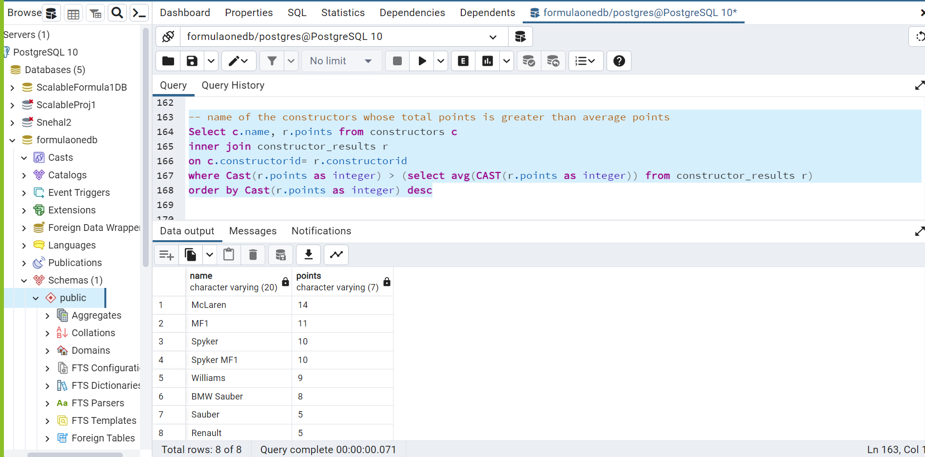

**Query 5 : which driver got the minimum points**

**(we have used min aggregation function )**

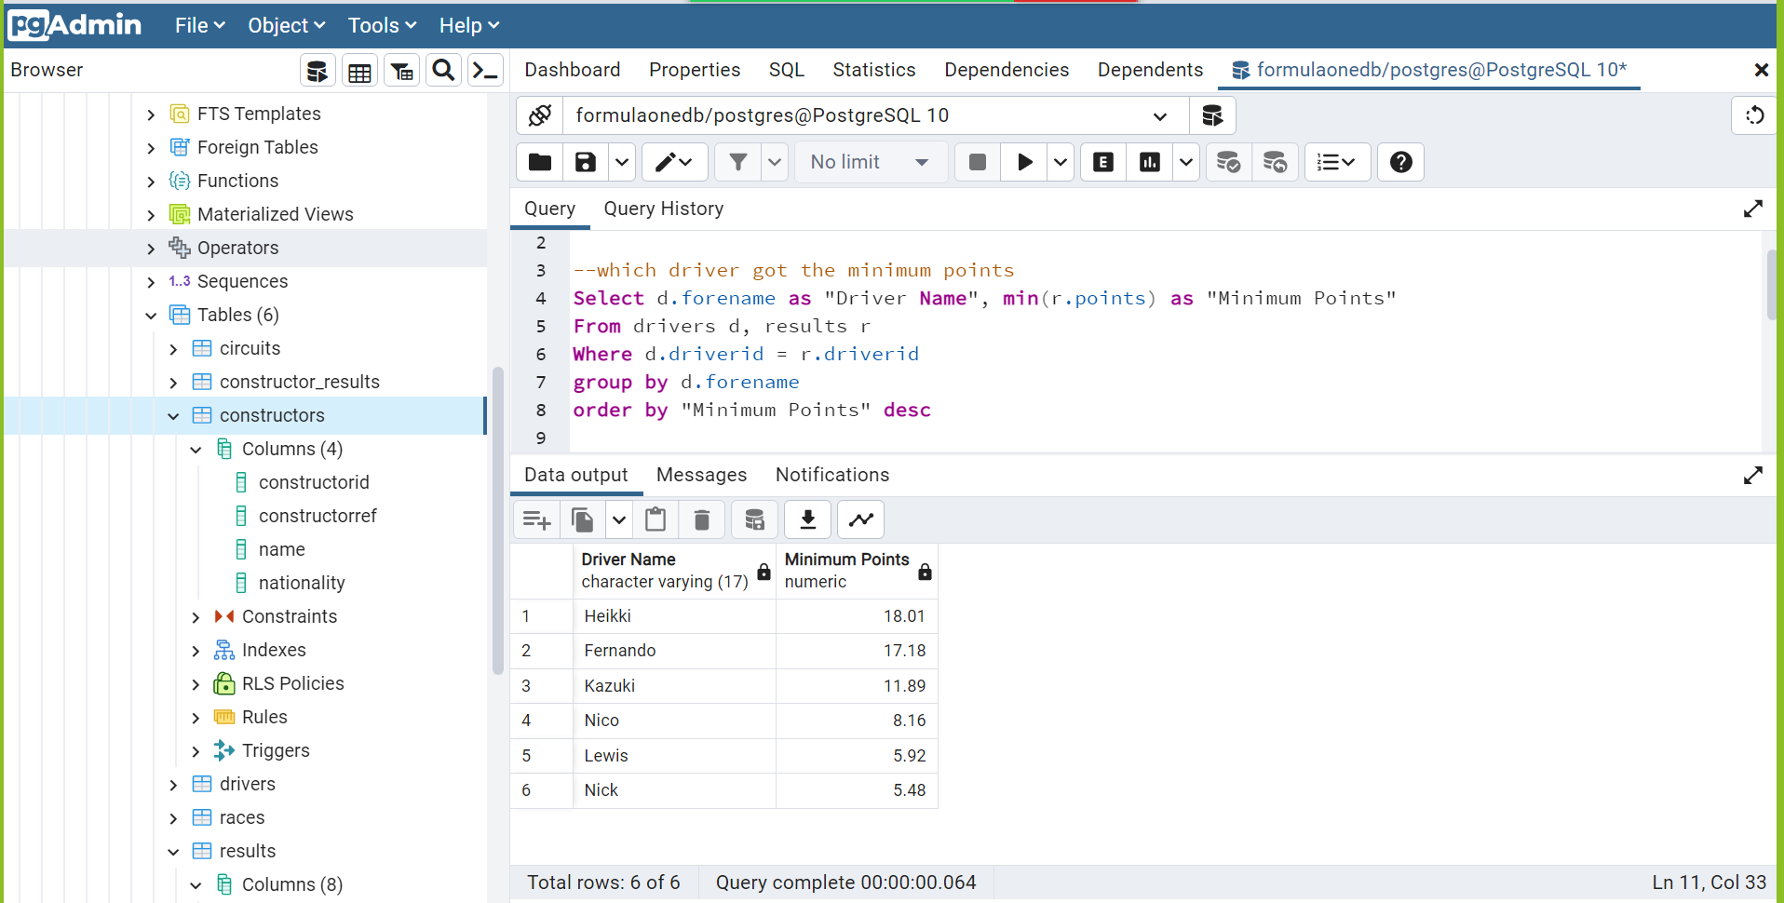

**Query 6 : which Driver got the Maximum points**

**(we have used max aggregation function )**

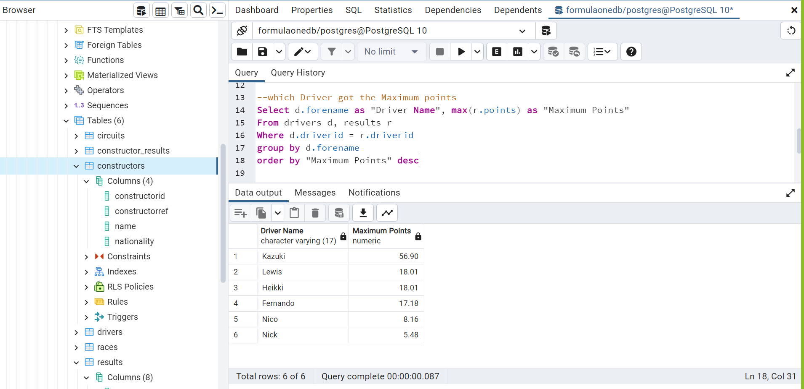

**Query 7 : Name of the constructors whose nationality is either British, German or Japanese**

**(We have used In, Like, And, OR operators)**

